HR POLICY ASSISTANT
Retrieval-Augmented Generation (RAG) Chatbot using n8n
Agentic AI Assignment 3
By: Sejal Varma (25030242065)

Contents
1. Project Overview
2. Problem Statement and Objectives
3. Domain and Knowledge Base
4. Retrieval-Augmented Generation Approach
5. Technology Stack
6. System Architecture
7. Workflow 1 — Document Ingestion
8. Workflow 2 — HR Policy Question Answering
9. Main Components and Their Roles
10. AI Agent Instructions and Grounding Rules
11. End-to-End Execution
12. Testing and Validation
13. Observations from the Current Execution
14. Limitations and Improvements
15. Conclusion
Appendix A — Suggested Test Questions
Appendix B — Sample System Prompt

1. Project Overview
The HR Policy Assistant is an AI-powered conversational application built using n8n and a Retrieval-Augmented Generation (RAG) architecture. It allows a user to ask questions about employee leave, attendance, working hours, and related workplace procedures. Instead of asking the language model to answer from general knowledge alone, the workflow retrieves relevant passages from a predefined HR policy document and uses that information to prepare a response.
The implementation contains two connected but separately executed workflows. The document-ingestion workflow downloads the HR policy document from Google Drive, loads and splits its contents into smaller chunks, generates embeddings, and stores the resulting vectors. The question-answering workflow receives a chat message, passes it to an AI Agent, and provides a vector-store search tool that can retrieve relevant policy content.
The knowledge base is a fictional HR Leave, Attendance and Employee Workplace Policy created for this academic demonstration. It includes explicit policy values, such as 18 annual leave days and 10 sick leave days for eligible full-time employees, alongside topics that are intentionally left unspecified. This allows the chatbot to be tested on both answerable questions and questions for which the policy does not contain an answer.

2. Problem Statement and Objectives

2.1 Problem Statement
Employees frequently need quick answers to questions about leave balances, application notice periods, approval responsibilities, attendance corrections, and workplace procedures. Searching a long policy document manually can take time. A general-purpose chatbot may also produce a plausible but unsupported answer when a policy detail is missing. This project addresses these issues by using document retrieval to ground responses in a controlled knowledge source.

2.2 Objectives
- Build a conversational RAG application using the visual workflow capabilities of n8n.
- Load an HR policy document from Google Drive as the source knowledge base.
- Split the document into smaller text chunks suitable for retrieval.
- Convert document chunks and search queries into vector embeddings.
- Store policy vectors and make them available through a vector-store search tool.
- Use an AI Agent and chat model to generate responses based on retrieved policy content.
- Reduce unsupported answers by instructing the agent to report when information is missing.
- Validate the workflow using questions whose answers are present and absent from the policy.

3. Domain and Knowledge Base

3.1 Selected Domain
The selected domain is Human Resources, specifically employee leave and attendance. The chatbot is named “HR Policy Assistant – Leave and Attendance.” It is designed to provide informational responses about the fictional rules in the supplied policy document. It is not connected to an employee management system and does not approve leave or modify employee records.

3.2 Knowledge Base Document
Document name: HR_Leave_Attendance_Policy.docx
The document contains the following sections:
- Introduction, purpose, scope, and general policy principles.
- Employee eligibility, including full-time, part-time, contract, probationary, and newly joined employees.
- Annual leave and sick leave entitlements, application notice, approval, cancellation, and extensions.
- Emergency leave, public holidays, working hours, breaks, and schedule changes.
- Attendance recording, late arrival, early departure, and attendance correction.
- Remote work, overtime, unpaid leave, and responsibilities of employees, managers, and Human Resources.
- Policy gaps and a list of test questions for evaluating the RAG chatbot.

3.3 Explicit Values in the Sample Policy
Policy topic | Rule stated in the knowledge base | Important qualification
Annual leave | 18 days per calendar year | For eligible full-time employees
Annual leave notice | At least 3 working days in advance | Submission does not mean approval
Annual leave approval | Reporting manager confirmation required | Pending requests are not approved
Sick leave | 10 days per calendar year | For eligible full-time employees
Illness notification | Inform reporting manager as soon as reasonably possible | Expected return date may be shared when possible
Attendance correction | Submit the request to Human Resources | The policy gives no fixed resolution deadline

The policy deliberately does not specify several values, including probationary employee entitlements, carry-forward rules, encashment, overtime rates, salary deductions for lateness, and a fixed manager response deadline. These gaps are useful for testing whether the agent avoids making assumptions.

4. Retrieval-Augmented Generation Approach
The project uses vector-based Retrieval-Augmented Generation. RAG combines a retrieval step with language generation. The document is first converted into searchable vector representations. When a user asks a question, the question is represented as an embedding and compared with stored document vectors. The most relevant text chunks can then be supplied to the AI Agent as evidence for its answer.

4.1 Why RAG Is Appropriate
- The knowledge base is domain-specific and may contain rules that differ from common HR practices.
- Exact values and eligibility qualifications should be retrieved from the source document.
- The source document can be updated and re-ingested without training a language model from scratch.
- The chatbot can be evaluated using questions with known answers and questions about omitted information.
- The approach separates document storage and retrieval from natural-language answer generation.

4.2 Two Stages of the RAG Pipeline
Stage 1 — Ingestion: retrieve the document file, load its content, split the text into chunks, generate embeddings, and store the embedded chunks in a vector store.
Stage 2 — Question answering: receive the user's question, use the AI Agent and its search tool to retrieve relevant chunks, and generate an answer grounded in those chunks.

5. Technology Stack
Technology / Component | Role in this implementation
n8n Cloud | Visual automation platform used to create, connect, execute, and inspect the workflows.
Google Drive | Stores the HR policy document and supplies the file to the ingestion workflow.
Google Drive Download node | Downloads the selected policy file using a configured Google Drive credential and file ID.
Default Data Loader / Load Policy Document | Loads document content for downstream processing.
Text Splitter / Split into Chunks | Divides the document into smaller text segments for embedding and retrieval.
OpenAI Embeddings | Converts document chunks and queries into numerical vector representations.
Vector Store / Store HR Policy Vectors | Stores the document chunks and their vectors for semantic search.
Chat Trigger / Chat with HR Policy Assistant | Receives user questions in the n8n chat interface.
AI Agent / HR Policy Agent | Decides when to use the search tool and composes the final answer.
OpenAI Chat Model | Generates natural-language answers based on the agent instructions and retrieved context.
Simple Memory (if configured) | Can preserve conversational context across messages in a session; it is not the policy knowledge base.

The screenshots supplied for this implementation show OpenAI Chat Model and OpenAI Embeddings nodes. This differs from the Ollama/Llama configuration in the reference example. The documentation therefore describes the models visible in the current workflow and does not claim that Ollama is being used.

6. System Architecture

6.1 Overall Architecture
DOCUMENT INGESTION
Google Drive → Read HR Policy → Load Policy Document → Split into Chunks
→ OpenAI Embeddings → Store HR Policy Vectors
QUESTION ANSWERING
Chat Trigger → HR Policy Agent → search_hr_policy Tool → Vector Retrieval
→ Retrieved Policy Context → OpenAI Chat Model → Response to User
The ingestion and question-answering workflows serve different purposes. The ingestion workflow prepares and stores the knowledge. The question-answering workflow uses the stored knowledge at query time. The vector store used by the search tool must refer to the same stored collection or namespace populated by the ingestion process.

7. Workflow 1 — Document Ingestion
The workflow is titled “HR Policy Assistant – Document Ingestion.” The provided screenshot shows the sequence Run Ingestion → Read HR Policy from Google Drive → Store HR Policy Vectors. The vector-store node has connected embedding and document inputs. The document input is supplied by Load Policy Document, which receives text-splitting support from Split into Chunks.

7.1 Node-by-Node Operation
Run Ingestion: Acts as the workflow's manual trigger. It allows the document-ingestion process to be run when the knowledge base is first prepared or after the source document has been updated.
Read HR Policy from Google Drive: Downloads the selected HR policy file from Google Drive. The node requires an authorized Google Drive credential and the correct file identifier.
Load Policy Document: Processes the downloaded file as document content and passes the resulting document data to the vector-store ingestion node.
Split into Chunks: Breaks the loaded policy into smaller segments. Chunking helps retrieval locate specific policy sections without needing to provide the entire document for every question.
Embeddings OpenAI: Creates a vector representation for each text chunk. These vectors capture semantic information used to match questions with relevant policy passages.
Store HR Policy Vectors: Receives document chunks and their embeddings and stores them in the vector store for later retrieval by the search tool.

7.2 Observed Ingestion Execution
The supplied execution screenshot reports a successful run. The visible execution log shows successful completion of Run Ingestion, Read HR Policy from Google Drive, Store HR Policy Vectors, Load Policy Document, Split into Chunks, and Embeddings OpenAI. The workflow canvas displays 33 items flowing through the document/vector-store path in that run. This is evidence that the displayed ingestion execution completed; it is not by itself a guarantee that every possible question will retrieve the ideal chunk.
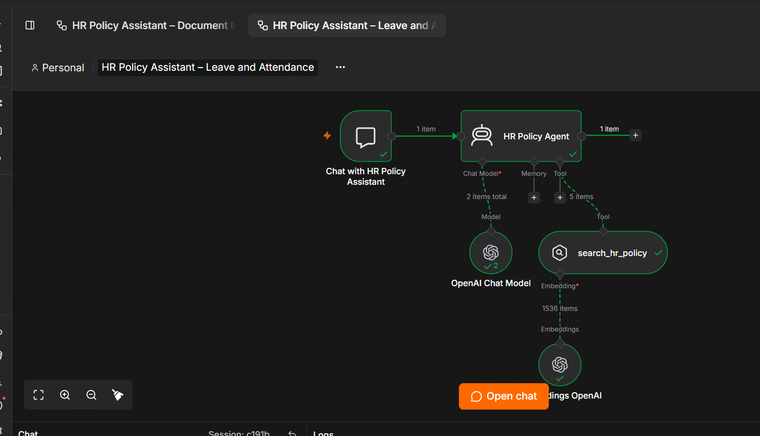
Figure 1. HR Policy Assistant — Document Ingestion workflow
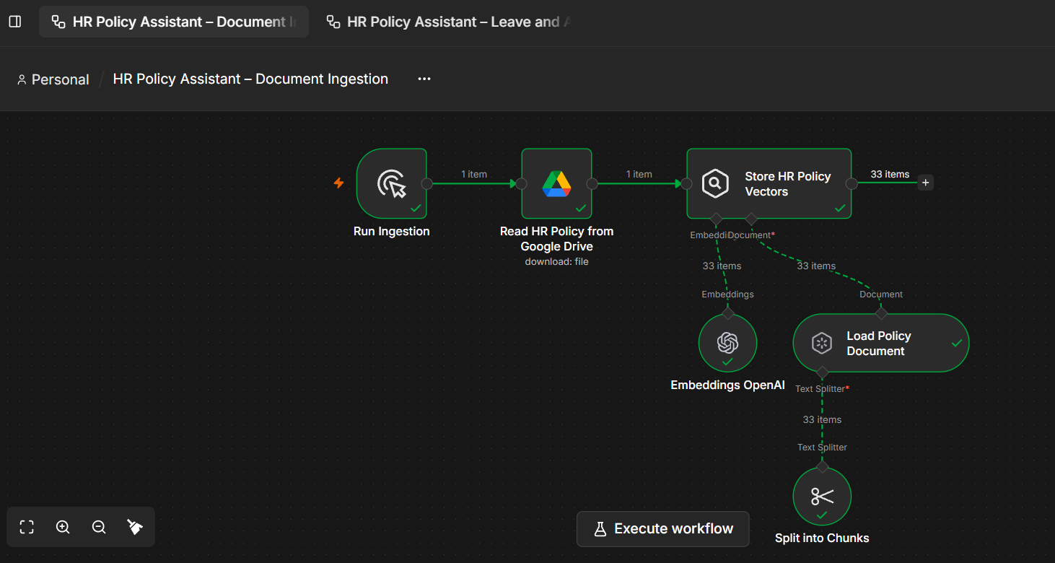
Figure 2. Successful execution log for the ingestion workflow

8. Workflow 2 — HR Policy Question Answering
The second workflow is titled “HR Policy Assistant – Leave and Attendance.” It receives user messages through the chat trigger and sends them to the HR Policy Agent. The agent has a chat model connection and a tool connection named search_hr_policy. The search tool is connected to an OpenAI embedding node so the user's question can be represented for semantic retrieval.

8.1 Node-by-Node Operation
Chat with HR Policy Assistant: Receives the question typed by the user in the n8n chat panel and starts the workflow execution.
HR Policy Agent: Processes the user's intent, follows its system instructions, and can call the policy search tool to retrieve evidence before composing an answer.
OpenAI Chat Model: Provides the language-generation capability used by the agent. It turns retrieved policy information into a readable response.
search_hr_policy: Acts as a tool available to the agent. Its description should clearly identify the HR policy knowledge base, the types of questions it should search for, and the rule against guessing missing values.
Embeddings OpenAI: Embeds the search query in a vector space compatible with the vectors created during ingestion. The embedding model and dimensions should be compatible across ingestion and retrieval.
Simple Memory, if connected: Can help the agent understand follow-up questions in the same conversation. Memory should not be treated as an authoritative source for policy rules.
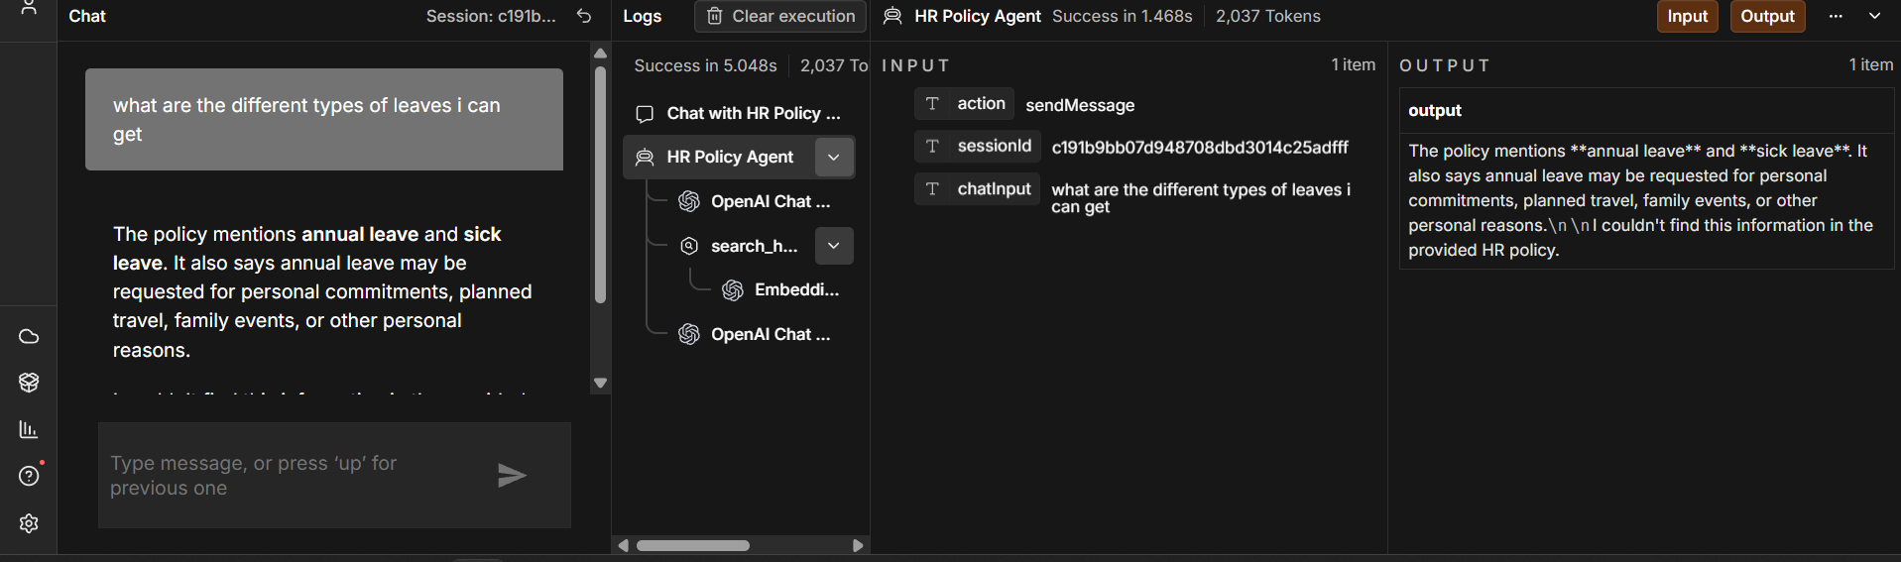
Figure 3. HR Policy Agent and connected search tool
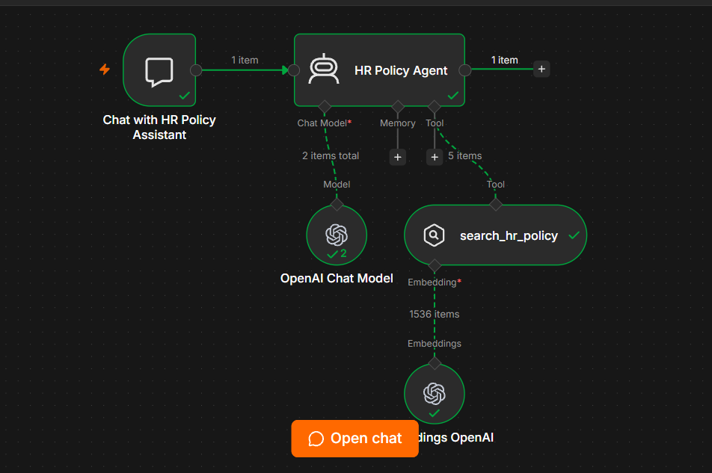
Figure 4. Question-answering workflow on the n8n canvas

9. Main Components and Their Roles

9.1 Google Drive Integration
Google Drive provides the source document for the knowledge base. The Drive node must point to the correct file. If the policy document is replaced or edited, the ingestion workflow should be run again so that the vector store reflects the updated content.

9.2 Document Loading and Chunking
The document loader and text splitter prepare readable text for embedding. Chunks that are too large may contain several unrelated policy topics, while chunks that are too small may omit important qualifications. A useful chunk should retain the policy statement together with relevant conditions, such as employee eligibility and approval requirements.

9.3 Embeddings
An embedding model maps text to a numerical vector. Similar meanings can be located by comparing the question vector with stored document vectors. The embedding model used at retrieval should be compatible with the one used to index the document; changing models generally requires re-embedding the knowledge base.

9.4 Vector Store
The vector store holds the indexed document chunks and their vector representations. The ingestion node populates it, and the search tool uses it to find relevant content. Because n8n's available vector-store nodes and persistence behavior can depend on configuration, the workflow should be tested after a fresh execution to verify that retrieval can access the stored records.

9.5 AI Agent and Chat Model
The AI Agent coordinates tool use and answer generation. The chat model does not automatically know which policy statements are authoritative; that behavior comes from the combination of the system prompt, retrieved document context, and tool use.

10. AI Agent Instructions and Grounding Rules
The agent should be configured as an HR Policy Assistant whose only factual source for company policy is the retrieved HR knowledge base. The following is a recommended system instruction for the implementation:
You are the HR Policy Assistant for Example Company.
Use the HR Leave, Attendance and Employee Workplace Policy retrieved through the search_hr_policy tool as your only source of factual information about company policy.
For questions about leave, attendance, working hours, remote work, overtime, or other covered HR rules, search the policy before answering.
Answer only with information explicitly supported by the retrieved policy text. Preserve qualifications such as employee type, leave category, notice period, and approval requirement.
Do not use general HR knowledge to fill gaps. Do not invent values, benefits, deadlines, deductions, or exceptions.
If the requested information is absent from the policy, say: "I couldn't find this information in the provided HR policy."
If only part of a multi-part question is answerable, answer the supported part and identify the missing part separately.
Use concise, professional language. Do not claim to approve leave or change employee records.

10.1 Important Grounding Rules
- Retrieve policy information before answering a policy-specific question.
- Apply a rule only to the employee category and leave type explicitly described in the document.
- Do not interpret a submitted leave request as approved.
- Do not invent rules for policy gaps such as carry-forward, encashment, overtime rates, or salary deductions.
- When the document does not support an answer, return the prescribed not-available response.

11. End-to-End Execution

11.1 Document Ingestion
- The user starts the ingestion workflow.
- n8n downloads the HR policy document from Google Drive.
- The document loader reads the content.
- The text splitter creates smaller chunks.
- The embedding node converts the chunks into vectors.
- The vector-store node saves the chunks and vectors for retrieval.

11.2 Question Answering
- The user submits a question through the n8n chat interface.
- The chat trigger passes the message to the HR Policy Agent.
- The agent uses its instructions to decide that the question requires policy evidence.
- The search_hr_policy tool searches the vector store using the embedded query.
- Relevant policy chunks are made available to the agent.
- The chat model produces a response using the retrieved policy information.
- The response is displayed to the user in the chat panel.

12. Testing and Validation
Testing should cover both factual retrieval and refusal to guess. The expected answers below are based on the fictional policy document used for this project.
Test | Question | Expected result
T1 — Direct fact | How many annual leave days are available to eligible full-time employees? | 18 days per calendar year.
T2 — Notice period | How early must annual leave be requested? | At least 3 working days before the intended start date.
T3 — Approval | Who approves annual leave? | The reporting manager must confirm the request.
T4 — Sick leave | How many sick leave days are provided? | 10 days per calendar year for eligible full-time employees.
T5 — Attendance | Who handles attendance corrections? | Human Resources.
T6 — Missing rule | Can unused annual leave be carried forward? | State that the information is not available in the provided policy.
T7 — Missing rule | What is the overtime payment rate? | State that the information is not available in the provided policy.
T8 — Employee category | How many leave days can a probationary employee take? | State that probationary employee leave eligibility is not specified.
T9 — Approval status | Is a pending leave request approved? | No. Approval requires manager confirmation.
T10 — Compound query | How many sick leave days do I get, and can they be encashed? | Answer 10 days for eligible full-time employees; state that encashment is unspecified.

12.1 Evaluation Criteria
- Correctness: the answer matches the policy wording and values.
- Grounding: the answer is supported by retrieved content.
- Completeness: the response includes important conditions and qualifications.
- Missing-information handling: the agent does not guess when the document is silent.
- Relevance: the agent applies the correct leave category or employee group.
- Consistency: equivalent questions receive substantively consistent answers.

13. Observations from the Current Execution
The supplied screenshot shows a successful execution of the HR Policy Agent for the question: "what are the different types of leaves i can get". The displayed answer identifies annual leave and sick leave, and explains that annual leave may be requested for personal commitments, planned travel, family events, or other personal reasons. The output also includes the sentence, "I couldn't find this information in the provided HR policy."
This run indicates that the workflow executed and produced a response, but the answer is not fully clean: it gives some relevant information and then appends the missing-information fallback even though the policy does name annual leave and sick leave. This is an observed answer-quality issue to address in the agent instructions and testing; it should not be described as a fully correct final answer.
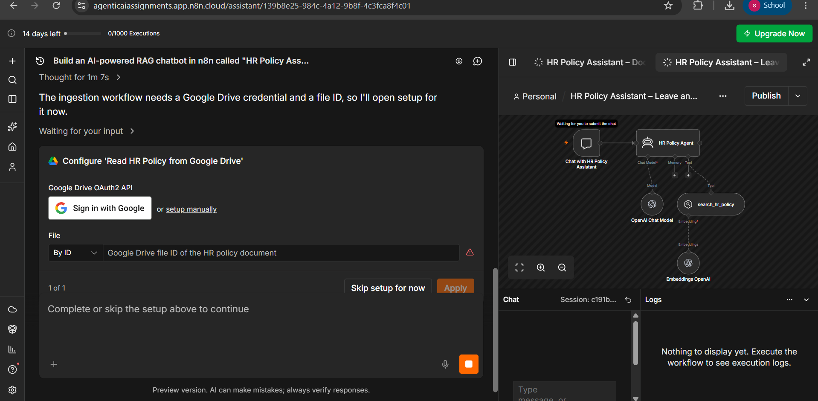
Figure 5. Test question and observed AI Agent output
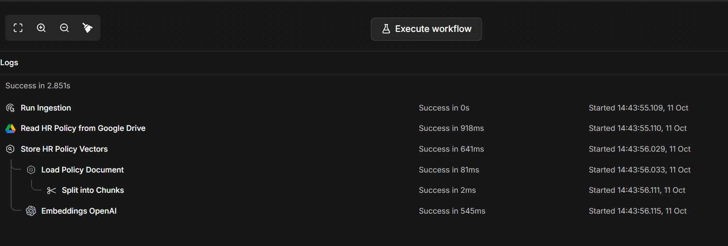
Figure 6. Additional execution screenshot supplied with the project

13.1 Recommended Correction
- Revise the system prompt so the fallback sentence is used only when the requested information is actually absent.
- Tell the agent to answer multi-part questions in two sections: “Available in the policy” and “Not specified in the policy.”
- Ensure the search_hr_policy tool description instructs the agent to search for relevant policy sections and use retrieved text as evidence.
- Test a simple question such as “How many annual leave days are available to eligible full-time employees?” before testing broad questions.
- Inspect the search tool's returned documents in the execution details to confirm that the expected policy chunk is being retrieved.

14. Limitations and Improvements

14.1 Current Limitations
- The chatbot is limited to the contents of the provided sample HR policy.
- The workflow does not connect to live employee records, leave balances, attendance systems, or approval systems.
- The agent can still produce inconsistent wording or add an unnecessary fallback, as seen in the sample test.
- A successful workflow execution does not guarantee that every question retrieves the best chunk.
- The behavior of the vector store and persistence depends on its node configuration and n8n environment.
- The sample policy is fictional and must not be used as real employment guidance.

14.2 Possible Improvements
- Add metadata such as policy section, topic, and employee category to improve retrieval precision.
- Tune the text-splitter chunk size and overlap, then compare results on the test-question set.
- Use consistent embedding configuration for both ingestion and retrieval.
- Add a retrieval threshold or a clear no-relevant-result path if supported by the chosen vector-store configuration.
- Display source sections or quoted policy evidence alongside answers where feasible.
- Add more test cases for ambiguous questions, multiple conditions, and missing information.
- Re-run ingestion whenever the policy document changes and verify that updated values can be retrieved.
- Avoid storing sensitive employee data in the demonstration knowledge base.

15. Conclusion
The HR Policy Assistant demonstrates how n8n can be used to build a RAG-based conversational application with a document-ingestion workflow and a separate question-answering workflow. Google Drive supplies the policy document, the loader and text splitter prepare the text, embeddings convert the chunks into vectors, and the vector store makes those chunks searchable. During chat, the AI Agent can use the search_hr_policy tool and a chat model to produce a natural-language response grounded in the retrieved information.
The supplied screenshots show that the ingestion workflow completed successfully and that the question-answering workflow executed. The sample chat response also highlights an area for improvement: the agent should not append a missing-information message when it has already identified a valid answer. Further testing and prompt refinement are therefore necessary to improve answer consistency and verify the chatbot's grounding behavior.

Appendix A — Suggested Test Questions
Category | Question
Annual leave | How many annual leave days do eligible full-time employees receive?
Annual leave | How early must I apply for annual leave?
Annual leave | Can I extend leave after it has been approved?
Sick leave | What should I do if I am too ill to attend work?
Attendance | What should I do if I forgot to record my attendance?
Remote work | How many days per week can I work remotely?
Overtime | What is the company's overtime payment rate?
Missing policy | Can unused annual leave be encashed?
Missing policy | Is a medical certificate required after two days of sick leave?
Policy application | Does the 18-day annual leave entitlement apply to contract employees?
Policy application | Is my leave approved if my manager has not responded?
Compound query | How many sick leave days are available, and can unused days be carried forward?

Appendix B — Suggested Vector Store Tool Description
Search the HR Leave, Attendance and Employee Workplace Policy for rules about annual leave, sick leave, emergency leave, leave applications, approvals, attendance, working hours, remote work, overtime, unpaid leave, and related HR topics. Use this tool whenever a user asks about a company policy. Retrieve relevant policy passages and answer only from the retrieved information. Preserve conditions such as employee category, leave type, notice period, and approval requirement. Do not use general HR knowledge or invent missing values. If the policy does not specify the requested information, state: "I couldn't find this information in the provided HR policy." For questions with both available and unavailable parts, answer the available part and clearly identify the part not specified.

